**EXCEL PROJECT**

**This is the excel file link of Walmart superstore dashboard:**

[**https://docs.google.com/spreadsheets/d/1trgifWN5Ag-CZh9fLO3U9JFPGlrZ8Qm8/edit?usp=sharing&ouid=101727593801684291068&rtpof=true&sd=true**](https://docs.google.com/spreadsheets/d/1trgifWN5Ag-CZh9fLO3U9JFPGlrZ8Qm8/edit?usp=sharing&ouid=101727593801684291068&rtpof=true&sd=true)



**Walmart superstore retail analysis**



**Madhav R. Yawale**

**DATA DICTIONARY**



**OBJECTIVE**

This project aims to conduct a thorough analysis of sales and profitability at Walmart Superstore, utilizing a dynamic dashboard to provide actionable insights for strategic decision-making and operational enhancement. The key features of the dashboard include:

1. **Visualizing Key Performance Indicators (KPIs)**: Employing Sparklines to present crucial metrics such as total sales revenue, profit margin, sales growth rate, and average transaction value. This allows stakeholders to quickly grasp performance trends.
2. **Analyzing Sales and Profitability Across Various Dimensions**: Segmenting sales and profitability data by customer segments, product categories, markets, and regions to uncover patterns and opportunities for optimization.
3. **Identifying Top-Performing and Underperforming Categories**: Using sales and profitability metrics to identify leading product categories driving revenue and profitability, while also pinpointing areas of underperformance for targeted improvement efforts.
4. **Visualizing Geographic Distribution and Market Share**: Visualizing the geographic distribution of sales and market share to identify growth opportunities and potential expansion areas across different regions.
5. **Understanding Contribution of Sub-Categories**: Analyzing the contribution of different sub-categories to overall sales to gain insights into consumer preferences and optimize inventory management and marketing strategies.
6. **Evaluating Market Share by Region**: Assessing market share by region to inform decisions on resource allocation, expansion strategies, and market penetration efforts.

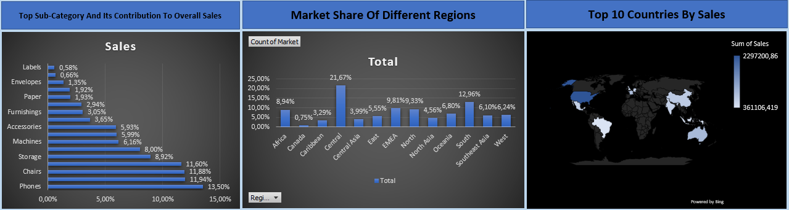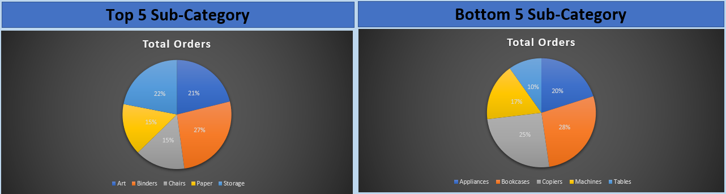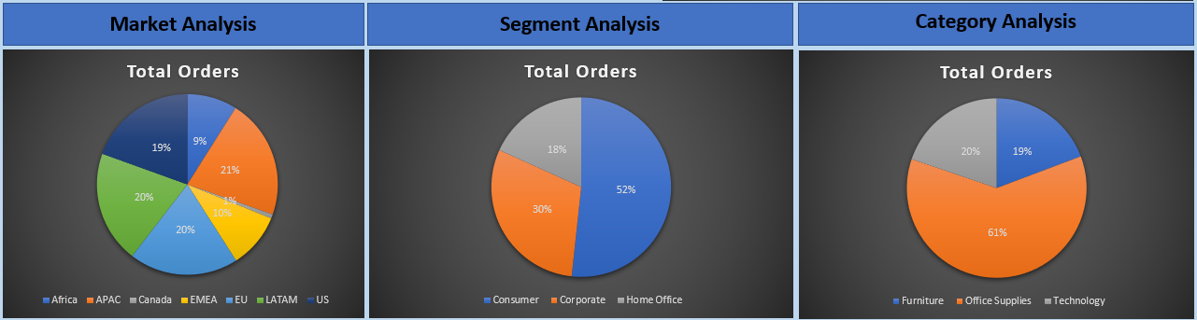

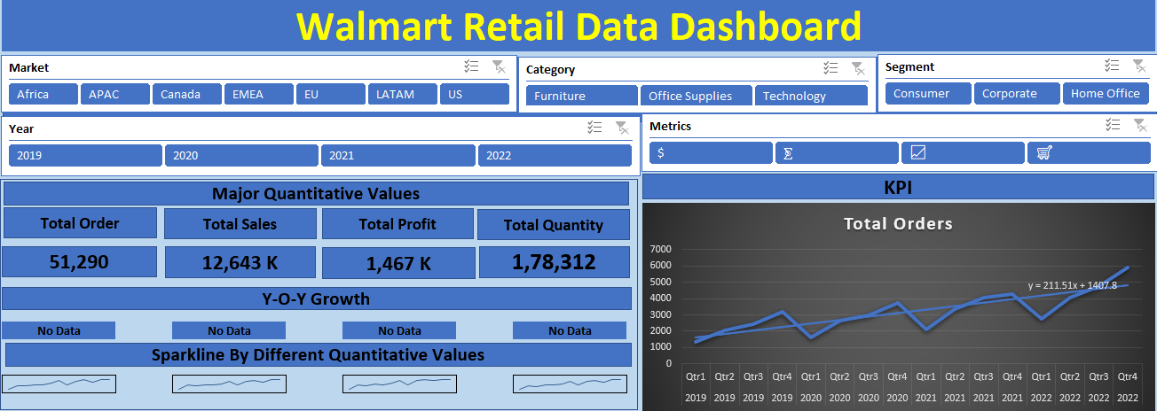

**WALLMART DASHBOARD**

**CONCLUSION**

In conclusion, the implementation of a dynamic dashboard for retail analysis of Walmart Superstore's sales and profitability offers invaluable insights for strategic decision-making and operational optimization. By leveraging key features such as visualizing KPIs, segmenting data across different dimensions, identifying top-performing and underperforming categories, and evaluating market share by region, stakeholders gain a comprehensive understanding of the store's performance landscape.

The dashboard facilitates quick identification of trends, opportunities, and areas needing improvement, empowering decision-makers to take targeted actions to enhance revenue, profitability, and market competitiveness. With detailed insights into customer segments, product categories, and geographic distribution, Walmart can refine its inventory management, marketing strategies, and expansion efforts effectively.

By estimating metrics at both category and sub-category levels, the dashboard enables granular analysis, ensuring no valuable insights are overlooked. Ultimately, this data-driven approach fosters agility and informed decision-making, positioning Walmart Superstore for sustained growth and success in the dynamic retail landscape.